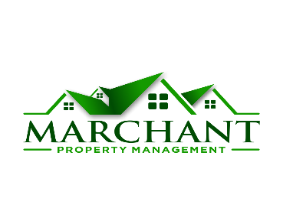
Electronic 1099 Option
Dear Clients,
We are excited to announce beginning in 2018 Marchant Property Management will be offering an option to only receive your 1099 via our web portal and for you to opt out of receiving a mailed copy. You will need to affirmatively consent, and you can do so through signing this form and you can email us back at accounting@marchantpm.com confirming your consent. This way you will not have to wait on the mail and will have it timelier.
If you decide you want a paper copy at any time after you send us your consent, you can email us at accounting@marchantpm.com. Your consent will be for all future years unless you decide you want a paper copy.
You must email us your consent, otherwise you will be mailed your 1099. We encourage you to Go Green by consenting and returning this form. Rather than having to wait for the mail you will be able to just download a pdf copy to email or print for doing your taxes.
To log into our web portal, go to www.marchantpm.com and click on Owner Login button on the top left. First timers then click on Create a password and follow the instructions. For help getting set up contact us at accounting@marchantpm.com or call us 864-527-4510.
Thank you for your continued business!

Respectfully,

Your Accounting Team
Marchant Property Management

Opt in for electronic 1099’s:
□ I, _____________________ affirmatively consent to only receive my 1099 electronically via our Owner web portal that is accessible 24/7/365 and opt out of receiving a mailed copy.

____________________________ ___________
Signature Date

